English 211 – 9th ACP Name:
kaplana@newton.k12.ma.us mrkaplanenglish.weebly.com Date:

Non-Fiction Reading Packet #1
“In the NBA…,” Calvin & Hobbes, “5 Steps…,” and Wes Moore

#1

In the N.B.A., ZIP Code Matters
by Seth Stephens-Davidowitz, Contributing Op-Ed Writer, The New York Times, Sunday Review
November 2, 2013 nytimes.com/2013/11/03/opinion/sunday/in-the-nba-zip-code-matters.html

The author, contributing writer to the Sunday Review, recently received a Ph.D. in economics at Harvard.

As the N.B.A. season gets under way, there is no doubt that the league’s best player is 6-foot-8 LeBron James, of the Miami Heat. Mr. James was born poor to a 16-year-old single mother in Akron, Ohio. The conventional wisdom is that his background is typical for an N.B.A. player. A majority of Americans, Google consumer survey data show, think that the N.B.A. is composed mostly of men like Mr. James. But it isn’t.
I recently calculated the probability of reaching the N.B.A., by race, in every county in the United States. I got data on births from the Centers for Disease Control and Prevention; data on basketball players from basketball-reference.com; and per capita income from the census. The results? Growing up in a wealthier neighborhood is a major, positive predictor of reaching the N.B.A. for both black and white men. Is this driven by sons of N.B.A. players like the Warriors’ brilliant Stephen Curry? Nope. Take them out and the result is similar.
But this tells us only where N.B.A. players began life. Can we learn more about their individual backgrounds? In the 1980s, when the majority of current N.B.A. players were born, about 25 percent of African-Americans were born to mothers under age 20; 60 percent were born to unwed mothers. I did an exhaustive search for information on the parents of the 100 top-scoring black players born in the 1980s, relying on news stories, social networks and public records. Putting all the information together, my best guess is that black N.B.A. players are about 30 percent less likely than the average black male to be born to an unmarried mother and a teenage mother.
Need more evidence? The economists Roland G. Fryer and Steven D. Levitt famously studied four decades of birth certificates in California. They found that African-American kids from different classes are named differently. Black kids born to lower-income parents are given unique names more often. Based on searches on ancestry.com, I counted black N.B.A. players born in California in the 1970s and 1980s who had unique first names. There were a few, like Torraye Braggs and Etdrick Bohannon. But black N.B.A. players were about half as likely to have a unique name as the average black male.
From 1960 to 1990, nearly half of blacks were born to unmarried parents. I would estimate that during this period roughly twice as many black N.B.A. players were born to married parents as unmarried parents. In other words, for every LeBron James, there was a Michael Jordan, born to a middle-class, two-parent family in Brooklyn, and a Chris Paul, the second son of middle-class parents in Lewisville, N.C., who joined Mr. Paul on an episode of “Family Feud” in 2011.
These results push back against the stereotype of a basketball player driven by an intense desire to escape poverty. In “The Last Shot,” Darcy Frey quotes a college coach questioning whether a suburban player was “hungry enough” to compete against black kids from the ghetto. But the data suggest that on average any motivational edge in hungriness is far outweighed by the advantages of kids from higher socioeconomic classes.
What are these advantages? The first is in developing what economists call noncognitive skills like persistence, self-regulation and trust. We have grown accustomed to hearing about the importance of these qualities for success in school, but players in team sports rely on many of the same skills.
To see how poor noncognitive skills can derail a career in sports, consider the tragic tale of Doug Wrenn. Mr. Wrenn was born five years before Mr. James, also to a single mother in a poor neighborhood. He, too, was rated among the top basketball players in high school. But Mr. Wrenn, unlike Mr. James, was notoriously uncoachable and consistently in legal trouble. He was kicked off two college teams, went undrafted, bounced around lower leagues, moved in with his mother and was eventually imprisoned for assault.
The second relevant advantage of a relatively prosperous upbringing is height. The economist Robert W. Fogel has demonstrated the impact of improved early life nutrition on adult height over successive generations. Poor children in contemporary America still have substandard nutrition, holding back their development. They have higher infant mortality rates and lower average birth weights, and recent research has found that poverty in modern America inhibits height. In basketball, the importance of every inch is enormous. I estimate that each additional inch almost doubles your chances of making the N.B.A.
The N.B.A.’s changing demographics may also reflect the advantages of growing prosperity. Even casual fans will have noticed the difference the past 30 years have made: In 1980, fewer than 2 percent of N.B.A. players were foreign-born; now more than 20 percent are.
Much of this is surely because of the increased international popularity of basketball. In 1992, a 14-year-old German, Dirk Nowitzki, watched the American team starring Mr. Jordan, Larry Bird and Magic Johnson win a gold medal in the Barcelona Olympics. Mr. Nowitzki, a childhood tennis and handball star, decided he wanted to become a basketball player. But there is a somewhat surprising factor that may also be contributing to the game’s internationalization: Foreign countries are producing taller men.
From 1900 to 1980, the average American adult male’s height rose to 5-feet-10 from 5-feet-6. But American height has leveled off since 1980. The number of American-born 7-foot N.B.A. players, which increased from 1 in 1946, the N.B.A.’s first year, to 16 in 1980, has leveled off as well (there were 20 last year). Western countries that have health patterns similar to those of the United States have also produced a fairly constant number of 7-foot N.B.A. players during the past few decades.
Meanwhile, other countries have caught up to the United States in health and height. A widely available proxy for early life conditions is infant mortality. In the United States, roughly 20 fewer infants per 1,000 births died in 2012 than in 1960. In other countries, declines have been much larger. In Turkey, over the same period, the rate dropped by a staggering 159 per 1,000 births. Even some Western European countries, like Spain, Greece and Portugal, had declines more than twice as large as those in America. All of these countries, recent research finds, have grown taller.
Take every country with bigger health improvements than the United States. Suppose they grew an inch on average in the past 30 years. This would most likely increase the proportion of 7-footers in these countries fivefold, and indeed these fast-improving countries have about five times as many N.B.A. 7-footers now as they did 30 years ago.
Or look at it from the other direction. Suppose Omer Asik, a 27-year-old Turkish player on the Houston Rockets, was born 25 or 30 years earlier, when Turkey’s children were much worse off. Perhaps he would have peaked as a 6-foot-10 forward in Ankara, not as a 7-foot center in Houston.
After winning his second N.B.A. championship last June, Mr. James was interviewed on television. He said: “I’m LeBron James. From Akron, Ohio. From the inner city. I am not even supposed to be here.” Twitter and other social networks erupted with criticism. How could such a supremely gifted person, identified from an absurdly young age as the future of basketball, claim to be an underdog? The more I look at the data, the more it becomes clear that Mr. James’s accomplishments are more exceptional than they appear to be at first. Anyone from a difficult environment, no matter his athletic prowess, has the odds stacked against him.

#2

Calvin and Hobbes, Bill Watterson, 1995.

#3

5 Steps To Success
by Amanda Kaiser on May 15, 2014
www.smooththepath.net/2014/05/15/5-steps-success-cartoon

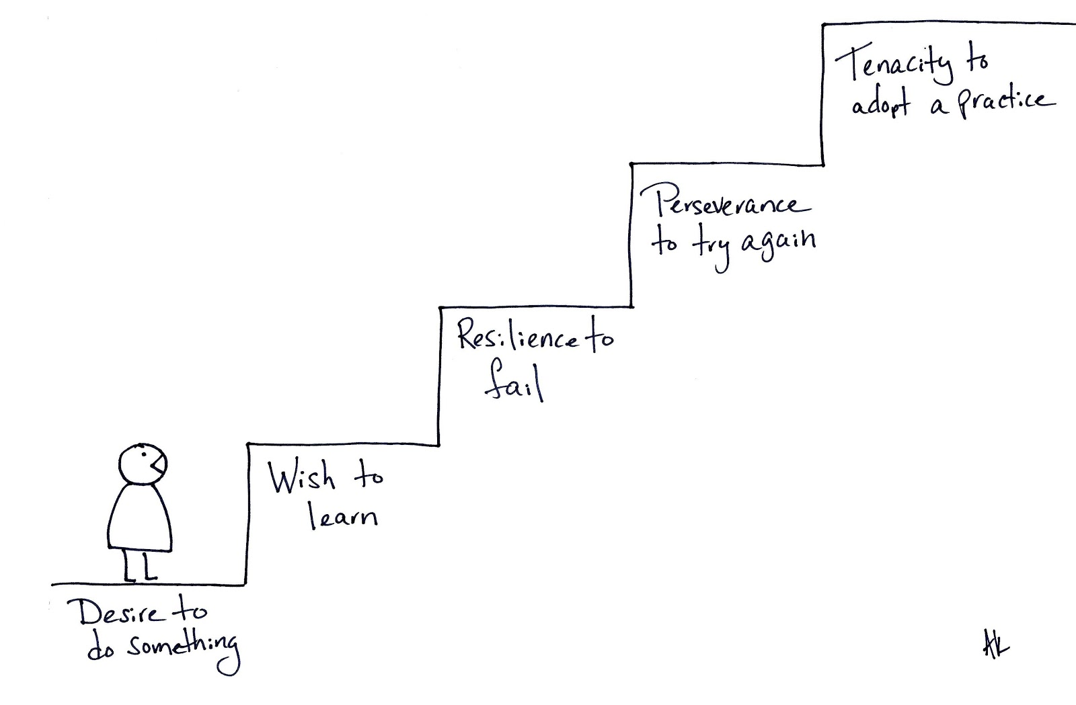

(Intro to The Other Wes Moore photocopied and attached here.)

